Influence of bait preference on abundance and species richness of butterflies

Tess van der Bel
Van Hall Larenstein
July 2023

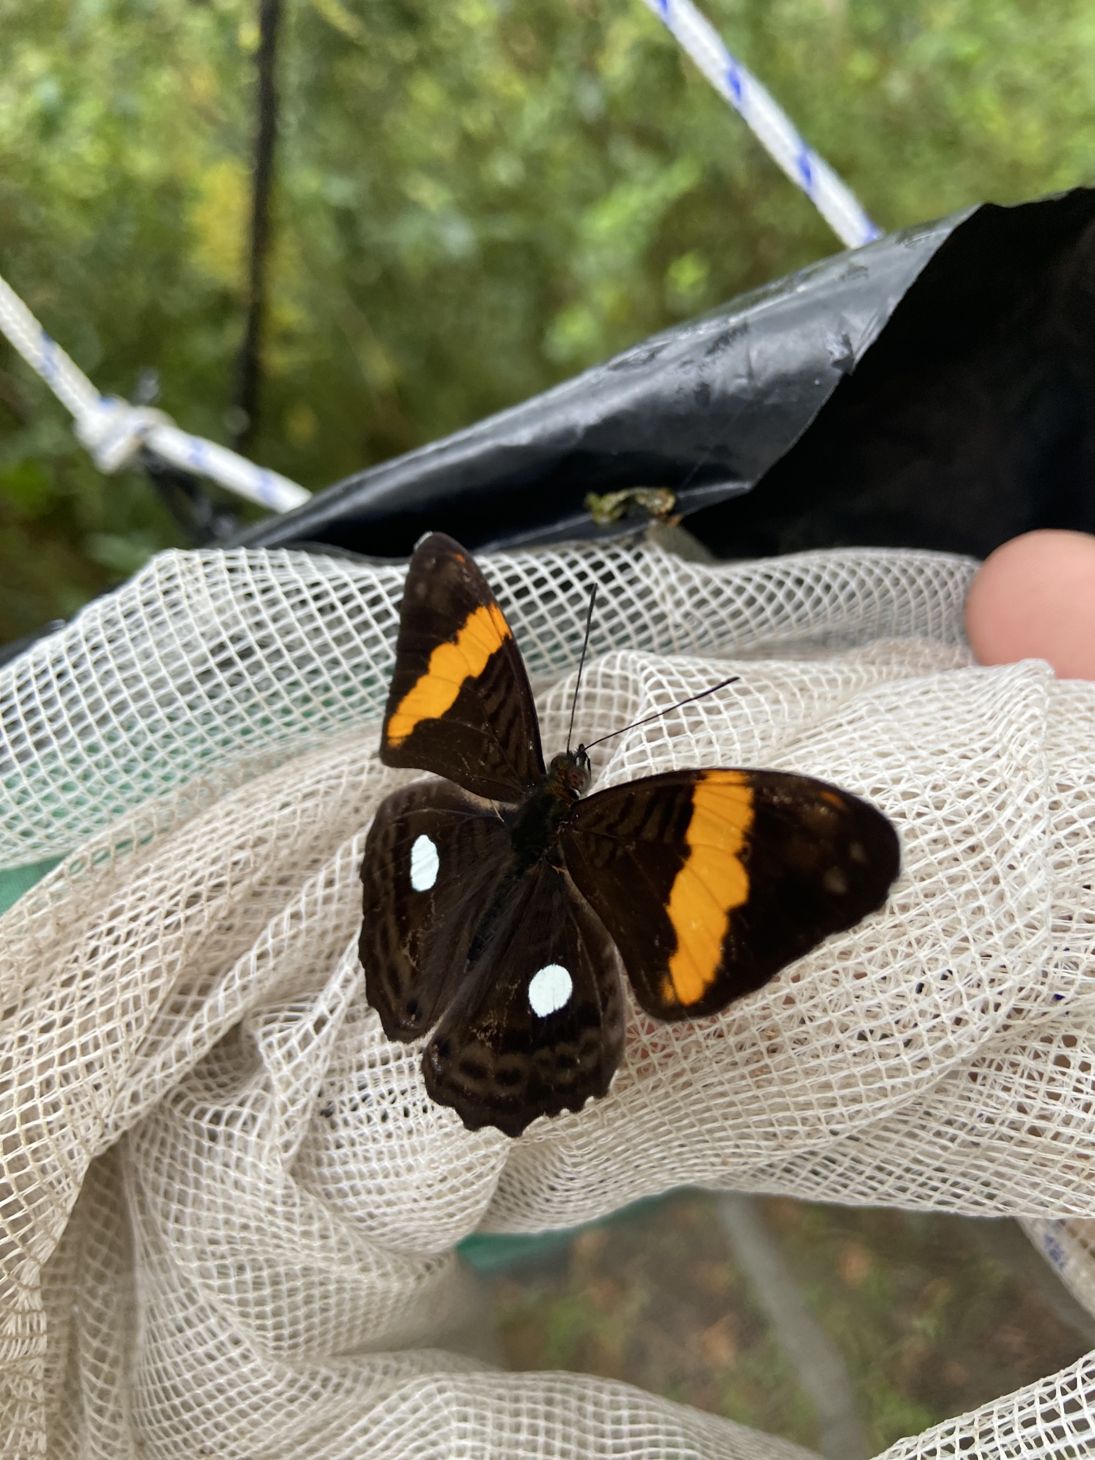
Adelpha Leucophthalma

Contents
Appendices 1
Tables 1
Figures 1
2 Abstract 2
3 Introduction 2
4 Study Location 2
5 Materials & Methods 4
5.1 Traps 4
5.1.1 Bait 5
6 Data Analysis 5
7 Results 6
8 Discussion 7
9 Conclusion (& Recommendations) 7
10 Acknowledgements 7
11 References 8

Appendices

Appendix A: Weather Classification Tables

Tables

Table 1: Study Sites 3
Table 2: Collected species 6
Table 3: Simpson diversity index 6

Figures

Figure 1: Map of reserve 3
Figure 2: Trap placement 4

Abstract
Many species of butterflies have specialised feeding preferences (DeVries, 1983). Therefore a lot is still unknown about the feeding behavior, which is why the aim of this study is to identify the influence of bait type on the abundance and species richness of butterflies. This was determined by collecting data by using butterfly traps. The data was collected in Cloudbridge Nature Reserve, Costa Rica. The results show no significant difference between species richness and bait type. There is however a significant difference between abundance and bait type. These findings will be further discussed.

Introduction

Most butterflies obtain the majority of their nutritional requirements from rotten fruits, decaying organic matter, feces, carcasses, and fermented sap (Bourlière, 1988). Rotten fruit that has fallen onto the ground is a common food source for butterflies. The composition of fruits, which is similar to the ones from nectar, not only contains carbohydrates and amino acids, but also contains vitamins and minerals as an additional source of nutrients (Molleman et al., 2005; Fischer et al., 2004). Sucrose, fructose, glucose, and maltose being the most favored sugar content by butterflies (Ômura & Honda, 2003; Erhardt & Rusterholz, 1998).
The rotten fruit being used as a food source has the smell of decaying fermentation (DeVries et al., 1997; Morais et al., 1995). It also produces a lot of products such as alcohol and organic acids, which are very useful as an attractant for fruit-feeding butterflies. Many species frequently seek excrements or animal carcasses to suck water and dissolved nutrients (Arms et al. 1974; Adler 1982; Adler and Pearson 1982). This is thought to be done in order to obtain essential nutrients, especially sodium (Larsen 1991).
Dietary shifts however can change the availability of different nutrients which would require a change in the animals feeding behavior and preference. The variety of the food preference is associated with the specialisations of the mouthparts (KRENN et al. 2001). Despite being known that these adaptations are associated with the food preference a lot is still unknown about the influence of the feeding behaviors.
Therefore the aim of this study is to identify if there is a significant difference in the abundance of butterflies caught with different types of bait.

Study Location
This study will be conducted in Cloudbridge Nature Reserve, Costa Rica. Cloudbridge Nature Reserve is a 255 ha, reforestation reserve on the Pacific slope of the Talamanca Mountains in Costa Rica. There are two rivers running through the reserve, Río Chirripó Pacífico and Río Urán.
Cloudbridge knows two main seasons, dry and wet season. The dry season runs from the later part of December through the early part of April. During the peak of the dry season (January-March) the total rainfall is about 113 mm. The wet season lasts from April till December, with rain occurring almost daily it has a total rainfall of about 2470 mm (Powell et al. 2022).
Cloudbridge holds 13 transects that are currently in use for butterfly surveys. Rio and Don Victor being the trails used in this study, run through an area of under 30 years of natural regeneration and through a planted area, as can be seen in table 1.

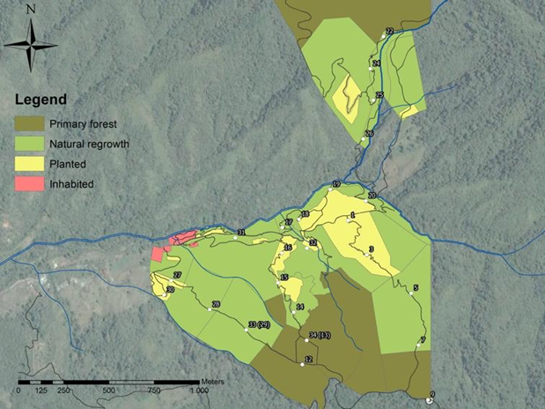
Figure 1. MAP OF RESERVE

Table 1. Study site
Site | Latitude | Longitude | Elevation (m) | Habitat Type | Trail
1 | 9.535556º | -83.839444º | 1623 | NR | Rio
2 | 9.580556º | -83.625000º | 1784 | P | Rio
3 | 9.664167º | -83.585278º | 1845 | NR | Don Victor
4 | 9.669722º | -83.581667º | 1730 | NR | Don Victor
P = Planted, NR = Natural Regeneration, O = Old Growth,

Materials & Methods

This research will be conducted with the use of baited live-trapping. For this survey method a certain location is chosen to set up the baited traps, which will be checked on a daily basis.
Traps will be set up at the selected locations on Tuesdays, with the first trap being set up around 8:00 am. The traps will be checked once a day from Tuesday through Friday. When needed, bait will be added or replaced to ensure optimal effectiveness. On Fridays the traps will be checked and bait will be covered until Tuesday.

Traps
The traps are built similar to the ones in the Butterfly Protocol (Powell & Spooner, 2016). The traps consist out of cylinder mesh tubes closed at the top, with bait sitting at a plate hanging about 3-4 cm from the bottom opening (see figure 2). There’s a gap at the bottom of the tube through which butterflies can enter. The gap between the mesh and the plate should be no more than five centimeter to minimize changes of the butterflies escaping. The butterflies can feed on the bait when located on the plate and since butterflies usually fly upwards when taking off they become trapped.
The traps used in this study are given an unique number to set them apart. Every selected location will have one understory trap and one canopy trap (figure 3). Traps will be placed away from the tree trunk to prevent animals from eating the bait and damaging the traps.
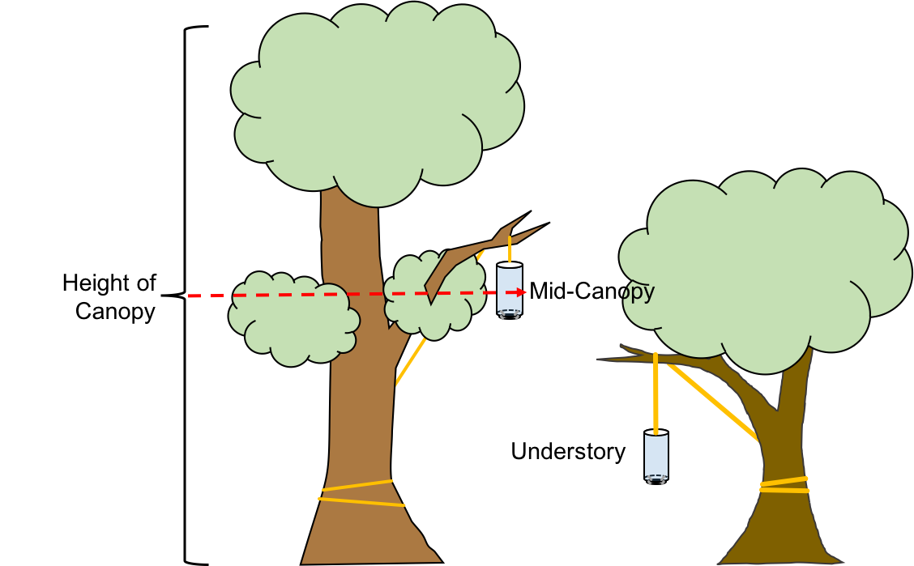
Figure 2. Trap placement
In order to check the traps the mesh should be pushed together at the bottom of the trap to prevent the butterflies from escaping. Once the plate with the bait is removed from the trap, a Ziplock bag can be used to gently catch the butterflies. This will be done by opening the ziplock back and slowly move it into the trap. Once a butterfly has entered the bag it can be closed and taken out of the trap. Photographs of the top and sides will be taken of the retrieved butterflies for later analysis.

Bait
In this study fermented banana and tuna are used as bait. The banana bait should be made a week in advance in order to have a sufficient amount of time to ferment. Tuna is bought from the store and banana is made with the following recipe:
Ingredients for 1 trap:
- ½ ripe banana,
- 1 teaspoon sugar,
- ¼ teaspoon yeast, and
- ¼ cup of water.
Instructions:
- Mash the bananas in a bowl.
- Add the sugar, yeast, and luke warm water and mix it.
- Divide the mixture into jars leaving about ½ of the jar empty to prevent the bait from exploding.
- Put the lid on the jar and put it into a sunny place.
- In order to keep the gases in the jar from building up too much, once a day:
  - Open the jar,
  - Cap the jar,
  - Shake vigorously,
  - Open the jar, and
  - Recap the jar.

Data Analysis
The chi-square goodness-of-fit test will be used to test for significant difference in the abundance and species richness of butterflies caught with the different types of bait. This will be done to figure out whether the observed bait preference differs from what is expected. The null hypothesis and alternative hypothesis for this are the following:
H1 = There is a significant difference in the abundance and species richness of butterflies caught with different types of bait.
H0 = There is no significant difference in the abundance and species richness of butterflies caught with different types of bait.
Afterwards the Simpson’s Diversity Index will be used to measure the diversity by taking into account the species richness as well as the abundance of each species.

Results
During this study a total of 49 individuals were caught in the traps. 43 of them are confirmed species with the other 6 being unidentified. Unidentified species were only taken into account for the abundance analysis. A total of 32 individuals have been caught with banana and 17 individuals with tuna.

Species | Banana | Tuna
Pteronymia Simplex Simplex |  | 1
Opoptera Bogotanus Alajuela | 1
Satyrotaygetis Satyrina | 18 | 4
Opsiphanes Cassina Chiriquensis |  | 5
Pseudomaniola Phaselis Rogersi |  | 1
Oxeoschistus Cothon | 3
Oxeoschitus Tauropolis | 1
Episcada Salvinia Opleri |  | 3
Anaeini | 1
Fountainea Glycerium Glycerium | 1
Eueides Procula Vulgiformis | 3
Phantos Callidryas |  | 1
Unidentified | 4 | 2
Total | 32 | 17
Table 2. Collected species
Chi Square test
Tuna and banana as bait attracted more individuals than expected. It is found that χ2 = 28,59 , df = 11, p < 0.05. Therefore we can reject H0 for both bait types and conclude that there is a significant difference.
Banana and tuna attracted less species than expected withχ2 = 10,99 , df = 11, p > 0.05. Therefore we can’t reject H0 for both bait types and conclude that there is not a significant difference.

Simpson diversity index
Table 3 shows that Tuna had the highest diversity since the value was closest to 1. This is followed by banana with the lowest diversity.

Bait type | SDI
Banana | 0,667339
Tuna | 0,852941
Table 3. Simpson diversity index

Discussion
The objective of this study was to determine whether there is a significant difference in the abundance and species richness of butterflies caught with different types of bait. The results indicate that there is a significant difference for banana as well as tuna as bait in regards to abundance. Therefore we can say that the bait type does have an influence on the abundance of butterflies.
Evolutionary dietary shifts may have an influence on these results. With the need to acquire certain nutrients from new food sources butterflies have developed certain behavioral and morphological adaptations (Sourakov et al. 2012). For example, advanced mouthparts to obtain nutrients from sources that weren’t accessible before (Krenn et al. 2001).
Both bait types attracted less species than expected. As can be seen in the results, there’s no significant difference when it comes to species richness. Therefore we can say that the bait type does not have an influence on the species richness.
Very little data was collected during this study which increases the chance of assuming as true a false premise. A study from 2021 showed opposite results on the influence of bait preference on species richness (Álvarez et al., 2021). This study conducted used fermented banana as well as rotten fish. The results for this study showed that traps baited with rotten fish captured a higher number of species. This contrast in results is potentially due to the difference in sample size.

Conclusion (& Recommendations)
The data showed that there is no significant difference between species richness and bait type. There was however a significant difference between abundance and bait type. It is recommended that future research on this topic should use multiple types of bait as well as multiple locations in order to obtain more data.

Acknowledgements
Thanks are due to all the Cloudbridge staff as well as the volunteers who joined me on my research. A special thanks to Anaëlle Meunier and Greilin Fallas Rodriguez with their statistical help.

References

Adler PH, Pearson DL (1982) Why do male butterflies visit mud puddles? Can J Zool 60:322-325
Adler, P. H. (1982). Soil-and puddle-visiting habits of moths. Journal of the Lepidopterists' Society, 36, 161-173.
Álvarez, C. F., Clavijo-Giraldo, A., Inés Uribe, S., Pyrcz, T. W., Iserhard, C. A., Lucci Freitas, A. V., & Marín, M. A. (2021). Sampling performance of bait traps in high Andean fruit-feeding butterflies. Neotropical Biodiversity, 7(1), 507-513.
Arms K, Feeny P, Lederhouse RC. 1974. Sodium: stimulus for puddling behavior by tiger swallowtail butterflies, Papilio glaucus. Science 185: 372-374.
Bourlière, F. (1988). DeVries, PJ—The Butterflies of Costa Rica and their Natural History. Papilionidae, Pieridae, Nymphalidae. Princeton University Press, Princeton, NJ et Guilford, Surrey, UK, 1987. Revue d'Écologie (La Terre et La Vie).
DEVRIES P.J. (1983) : Checklist of Butterflies. — In: JANZEN, D.H.
(ed.): Costa Rican Natural History, The University of Chicago Press, Chicago & London: 654-678
DeVRIES, P. J., Murray, D., & Lande, R. (1997). Species diversity in vertical, horizontal, and temporal dimensions of a fruit-feeding butterfly community in an Ecuadorian rainforest. Biological journal of the Linnean Society, 62(3), 343-364.
Erhardt, A.; Rusterholz, H.. 1998. International association for ecology: Do peacock butterflies (Inachis io L.) detect and prefer nectar amino acids and other nitrogenous compounds. Oecologia 117 536–542.
Fischer, K., O'brien, D. M., & Boggs, C. L. (2004). Allocation of larval and adult resources to reproduction in a fruit-feeding butterfly. Functional Ecology, 656-663.
Krenn HW, Zulka KP, Gatschnegg T (2001) Proboscis morphology and food preferences in nymphalid butterflies (Lepidoptera: Nymphalidae). J Zool 254:17–26
Larsen TB (1991) The butterflies of Kenya and their natural history. Oxford University Press, Oxford
Molleman, F., Van Alphen, M. E., Brakefield, P. M., & Zwaan, B. J. (2005). Preferences and food quality of fruit‐feeding butterflies in Kibale Forest, Uganda 1. Biotropica: The Journal of Biology and Conservation, 37(4), 657-663.
Morais, P. B., Martins, M. B., Klaczko, L. B., Mendon a-Hagler, L. C., & Hagler, A. N. (1995). Yeast succession in the Amazon fruit Parahancornia amapa as resource partitioning among Drosophila spp. Applied and environmental microbiology, 61(12), 4251-4257.
Ômura, H.; Honda, K. 2003. Feeding response of adult butterflies, Nymphalis Xanthomelas, Kaniska canace and Vanessa indica, to components in tree sap and rotting fruits: Synergistic effects of ethanol and acetic acid on sugar responsiveness. J. Insect Physiol. 49 1031–1038.
Powell, J. R., Slifkin, J. P., Spooner, F. T., Roth, J., Allnatt, L., Andrews, R., & Smokoska, M. (2022). Bird species inventory in secondary tropical montane cloud forest at Cloudbridge Nature Reserve, Talamanca Mountains, Costa Rica. Check List, 18(1), 17-65.
Powell, J., & Spooner, F. (2016b). Butterfly Survey Protocol. Cloudbridge Nature Reserve.
Sourakov A, Duehl A, Sourakov A (2012) Foraging behavior of the blue morpho and other tropical butterflies: the chemical and electrophysiological basis of olfactory preferences and the role of color. Psyche. doi:10.1155/2012/378050
Appendix A: Weather Classification Tables

Table A-1 – Rain Class
Rain Class |  | Conditions
0 | None | No rain.
1 | Drizzle | Barely raining. Tiny raindrops, very sparse or erratic rainfall. Rain gear not necessary.
2 | Light | Rain falling at a steady rate, but sparse. Would get soaked if out for an extended period without rain gear.
3 | Moderate | Rain constant and dense. Would get soaked in minutes without rain gear.
4 | Heavy | Raindrops large and falling with force. Streams forming on some trails. Would get soaked immediately without rain gear.
5 | Severe | Storm conditions. Sheets of rain falling from the sky. Trails become creeks. Dangerous to be out at all.

Table A-2 - Wind Class
Wind Class |  | Conditions
0 | Calm | Calm. Smoke rises vertically.
1 | Faint | Fog and smoke drift indicates wind direction. Leaves stationary.
2 | Light | Wind felt on exposed skin. Leaves rustle.
3 | Moderate | Leaves and small twigs constantly moving. Light flags extended.
 |  | Dust and loose paper raised. Small branches begin to move.
4 | Strong | Branches of a moderate size move. Small trees in leaf begin to sway.
 |  | Large branches in motion. Umbrella use becomes difficult. Empty plastic bins tip over.
5 | Severe | Whole trees in motion. Effort needed to walk against the wind.

Table A-3 – Cloud Cover Class
Cloud Class |  | Conditions
0 | Clear | No clouds.
1 | Mostly Clear | A few scattered clouds.
2 | Partly Cloudy | An equal amount of clouds and clear sky.
3 | Mostly Cloudy | More clouds than clear sky.
4 | Overcast | Full cloud cover.
5 | Misty | Low lying clouds (fog).

